**NVIDIA CUDA Installation on WSL2 Ubuntu-20.04 on Windows11**

**Overall View:**

**Main Instruction Guide: https://docs.nvidia.com/cuda/wsl-user-guide/index.html**

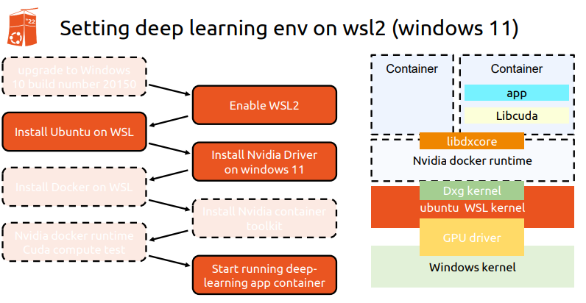

**Step 1**: **Enable WSL2.**

**Step 2**: Install **Ubuntu** on **WSL2** or **Ubuntu-20.04 from Microsoft Store.**

**Step 3: Install Nvidia Driver and Cuda Toolkit on Windows 11.**

**3.1 Nvidia Driver for Windows11:**

[**https://developer.nvidia.com/cuda/wsl**](https://developer.nvidia.com/cuda/wsl)

[**https://www.nvidia.com/Download/index.aspx**](https://www.nvidia.com/Download/index.aspx)

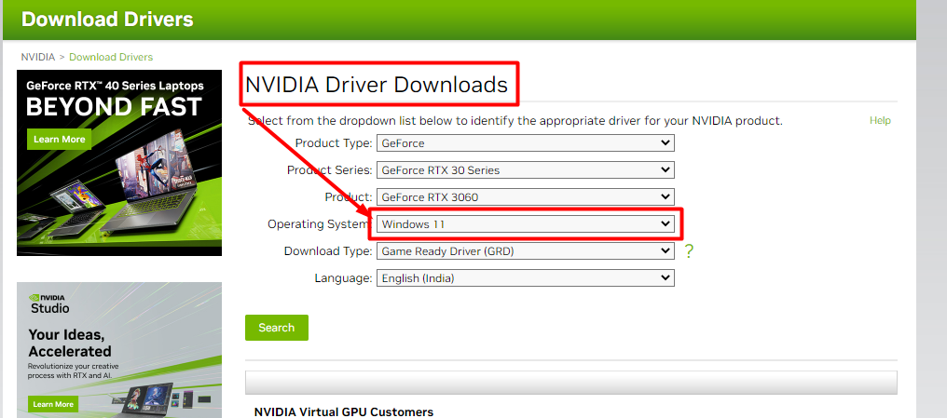

**3.2 Download Cuda Toolkit Download:**

[**https://developer.nvidia.com/cuda-downloads**](https://developer.nvidia.com/cuda-downloads)

**Step4: Follow the Guide of this Link :** [**https://docs.nvidia.com/cuda/wsl-user-guide/index.html**](https://docs.nvidia.com/cuda/wsl-user-guide/index.html)

4.1 **Open Ubuntu from start menu**

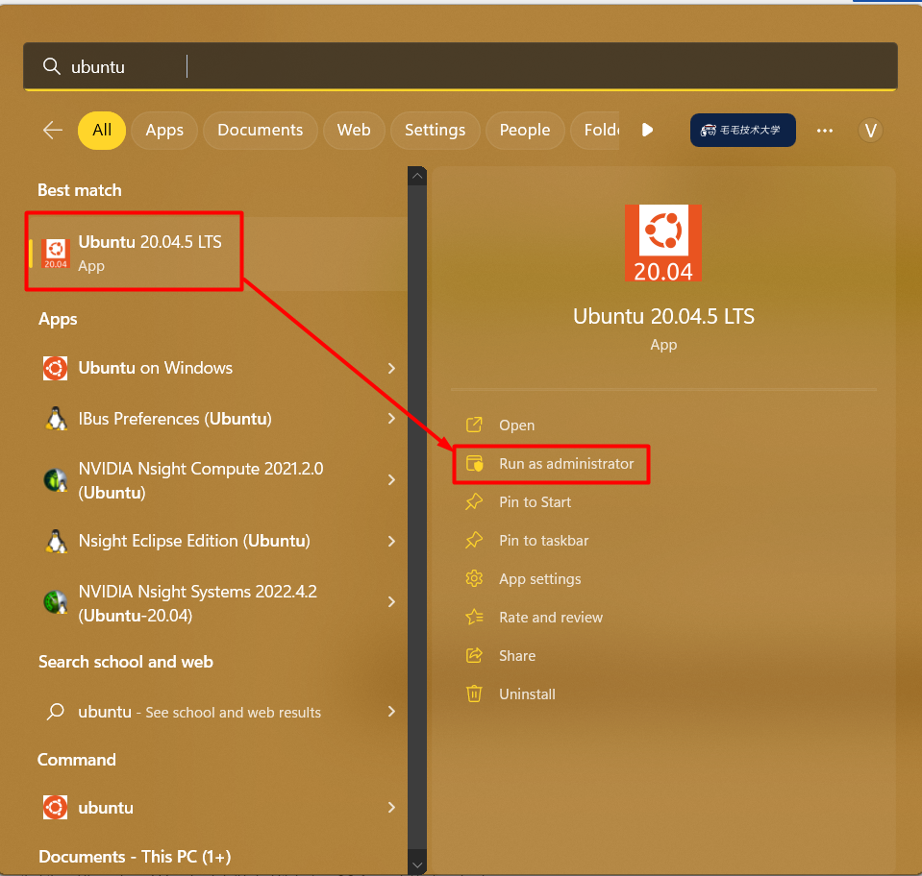

4.2 **Ubuntu-20.04 Terminal Looks Like this:**

4.3 Commands to execute on above terminal:

**Step1 : Execute below command**

sudo apt-key del 7fa2af80

**Step2: Open this link :** [**https://developer.nvidia.com/cuda-downloads**](https://developer.nvidia.com/cuda-downloads) **and select below option.**

**Step3: Copy Above All command and paste it on Ubuntu Terminal**

**and end will be look like this.**

**Step4: For checking local GPU on Ubuntu Terminal Type nvidia-smi and it will display gpu configuration**

**Step5: Now time to check the Docker terminal test of Nvidia.**

**Docker Command:**

docker run --gpus all nvcr.io/nvidia/k8s/cuda-sample:nbody nbody -gpu -benchmark

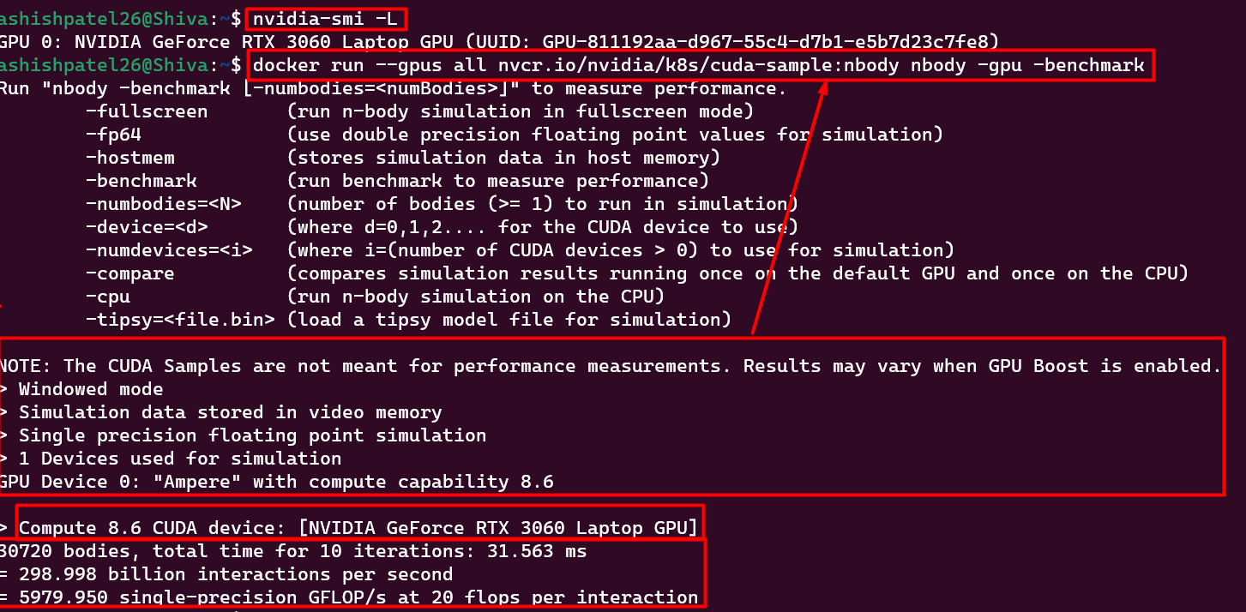

**Step 6: Now Run the tensorflow docker file and run on GPU.**

docker run --gpus all -it --name tfgpu -p 8888:8888 -v ${PWD}:/tf/notebooks tensorflow/tensorflow:latest-gpu-jupyter

